4/10 Meeting Notes

- Find slide deck in winter quarter lecture materials: https://canvas.uw.edu/courses/1861680/files/folder/PGST%20-%20Data-Meetings-Reports?preview=145119152
- Example of using bill data:
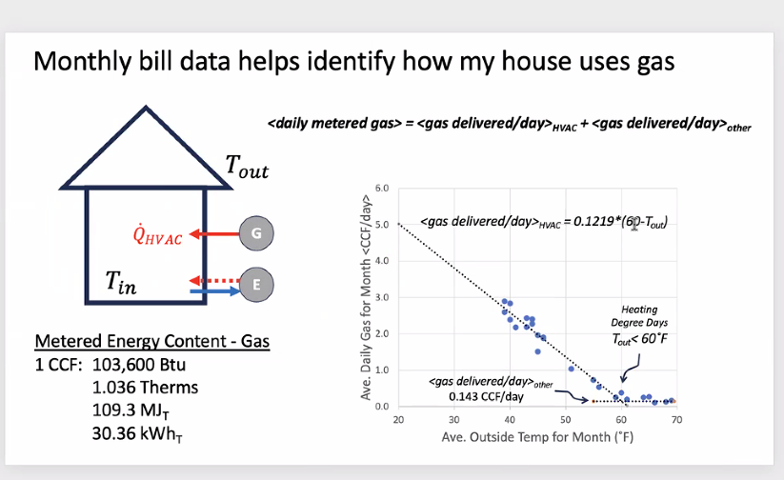
  - Line for boiler if it makes up 60% of heating demand would be ~ 60% of the slope of the overall line
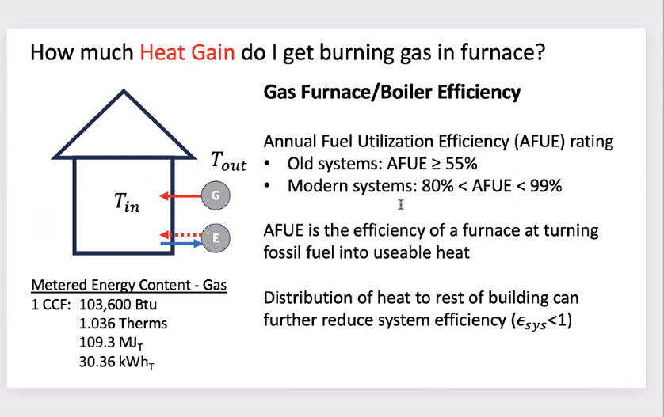
  - 80% AFUE - Only 80% ends up being heat going into house
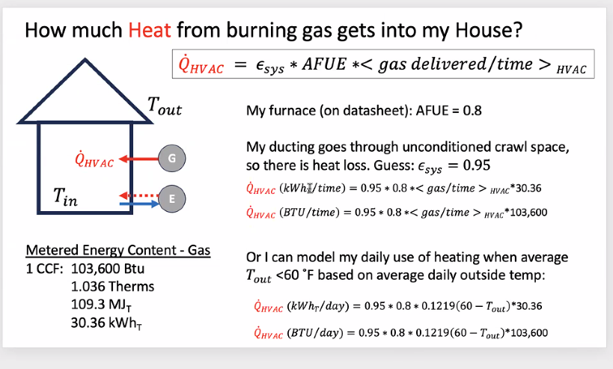
  - 83% efficiency, can assume any heat loss is on inside of building so ductwork efficiency ~ 100%
- Energy making it into house:
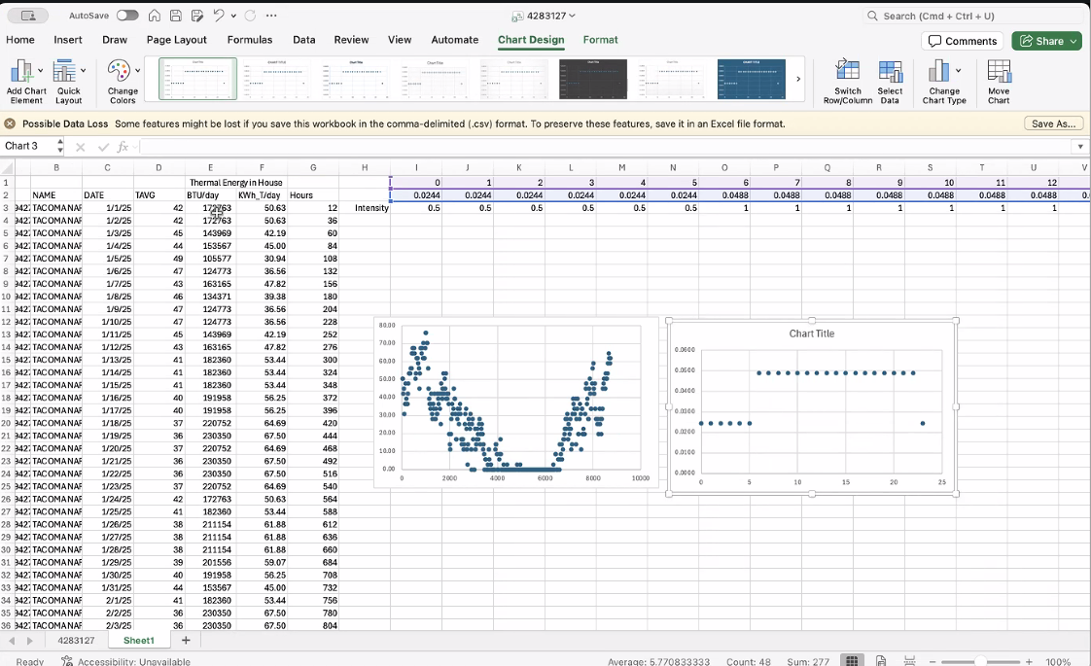
  - Over a year of 8760 hours, these are kWh_{T} (thermal) over these hours of the year.
- Hourly load in year and in a day:
- 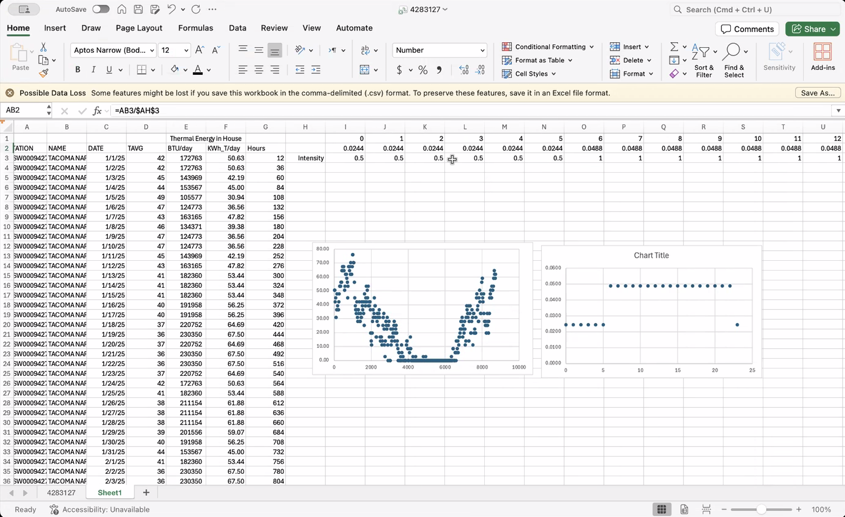
  - This is how he would show and describe monthly data on propane use. Separate out heating and cooling
  - He thinks they have a uniform thermostat - meaning energy usage is much more uniform
  - Can put some sort of mask on hours when more or less to try and estimate peak demands, doesn’t necessarily need to be a sinusoidal plot.
  - He would do a daily with all 7 days the same, maybe make a 7 day mask that we put over the top of things.
  - That would be heating, put over baseload stuff for things that don’t do heating.
- AFUE = annual fuel utilization efficiency (AFUE)
  - Ductwork in contact with cold spaces, causes heat loss. But since our situation is a boiler inside building with hot tubes inside building, heat loss just heats building and there is no ductwork-related loss.
  - Longhouse: tubing crosses into unconditioned space in ground, he doesn’t know how it is insulated. Most of the tubes’ length is in the floor, he would just call efficiency also 1.
- At 99% efficiency: heat exchanger on the flue gas, recovering heat. Below 80% is bad design of the heat exchanger box. If we don’t have a good HX for exchanging cold with hot air, it wastes heat. Getting hot water out - we can condense that and use it, more efficient than hot gas.
  - Furnace with white smoke coming out is steam, exhaust pipe would have steamy smoke coming out (uncondensed water) - about 80%
  - Water is a better heat conduction medium than blowing out air, but our system is still clearly venting hot steam out rather than condensing and recovering heat.
- Make a plot of a general schedule for activities in the building. Since we would make a profile for hours, we could show all intensity during lunchtime/dinner with use of the gas stove.
  - Make something really approximate for now, and can refine it based on feedback.
  - Need to consider how humans act and how it relates to energy use.
- We should try to start organizing a continuous PowerPoint with stuff that is completely done, can refer back to it and Rachel can look at it too.
  - Organize into chunks of tasks, will make writing our report much easier
  - Have useful figures, past data analysis compiled, catalog progress
- Have macroscopic sniff tests - e.g., spent this much energy in a year vs. in a month - do numbers add up? Constantly do internal checking.
- Fridays - 12:30-1:30pm:
  - He can do next week, but not the week after. He can adjust some of his time windows, see what he can do. Two weeks that he will have conflicts. We can try to work around that.
  - Can also email/schedule one on one with focused questions/needs for individual people. Much easier to schedule if needed to get useful information for someone quickly.
  - We were thinking of setting a 7pm deadline to email him slides/info for him to give feedback.
- Thursday deadline, Friday meeting
  - Dr. Schwartz has commute - wouldn’t be able to talk a ton. Maybe set internal 4pm deadline on Thursdays - valuable to get quick feedback.
- Wastewater treatment solar and clinic:
  - Clinic on net metering and WWTP is net billing.
  - Rachel says WWTP never produces more than the wastewater plant uses, so they only save on retail energy prices. They never export power from WWTP since panels only produce a fraction of their needs.
  - Different schemes because the state of Washington paid for the clinic, but with WWTP the utility would only pay the wholesale rate.

- Boiler
- Capital cost - check efficiency numbers and whether I need to consider efficiency.
  - Should be all good - no efficiency info in the source I used.
- Send email to Dr. Schwartz with sources for these numbers.
- ReOpt should in BAU give the propane costs and electricity costs. If electric boiler is set to produce the same heat as propane boiler and set to the same schedule PSE is using, it should calculate it.
  - Do this in ReOpt
- Spread out propane data hour by hour over a year, then use 83% of that propane energy in Btus to find electric consumption. Put this into usage by day or by week, not by month.

